Please enter the relevant fields in ‘File/Properties’, ‘Summary’ tab.
Complete the table below, using only one A4 page.
Contractual Date of Delivery to the EC: | [ISO format]
Actual Date of Delivery to the EC: | [ISO format]
Workpackage: | WP4.1
Author(s) and Institutions
Estimated Staff Months:
Dissemination Level:
Nature: | [eg a report, or software …]
Approval Status:
Version:
Total Number of Pages: | 25
Filename: | KS-AP3.4.22-UEP-2006-08-25-Administrative metadata in MPEG7-v1.0.doc
Keyword list:
Abstract

The information in this document reflects only the author’s views and the European Community is not liable for any use that may be made of the information contained therein. The information in this document is provided as is and no guarantee or warranty is given that the information is fit for any particular purpose. The user thereof uses the information at its sole risk and liability.

History

Version | Date | Reason | Revised by
1.0 | 25.8.2006 | - | M.Vacura

Authors

Partner | Name | Phone / Fax / Email
UEP | Miroslav Vacura | vacuram@vse.cz

Table of Contents

1 Executive Summary 4
2 Abbreviations and Acronyms 5
2.1 Glossary 6
3 K-Space Ontology Module 6 – Describing administrative metadata 7
3.1 Defining administrative metadata 7
4 Standard MPEG-7 7
4.1 Creation information 8
4.1.1 Creation DS 8
4.1.2 Classification DS 9
4.1.3 RelatedMaterial DS 11
4.2 Media Information 12
4.2.1 MediaIdentification D 13
4.2.2 MediaProfile DS 13
4.2.3 MediaInstance DS 14
4.3 Usage Information 14
4.3.1 Rights Datatype 15
4.3.2 Financial Datatype 16
4.3.3 Availability DS 16
4.3.4 UsageRecord DS 18
5 Standard NISO Z39.87 -200x – Data Dictionary 19
5.1 Identification 19
5.2 Source information 19
5.3 General Capture Information 20
6 Conclusion 23
7 References 24

Executive Summary

Abbreviations and Acronyms

Glossary

K-Space Ontology Module 6 – Describing administrative metadata

Module 6 of K-Space ontology focuses on describing administrative metadata. This document provides overview of most important parts of MPEG-7 standard for this purpose and also of some aspects of NISO Z39.87 -200x standard draft.

Defining administrative metadata

The administrative metadata should provide information regarding how the digital data objects were created and stored, intellectual property rights, the original source object from which the digital library object derives, and information regarding the provenance of the files comprising the digital library object.

Provenance metadata usually concerns 6 Ws: Who, What, When, Where, Why, How. It generally covers information concerning data creation, changes, and possibly erasing. Provenance metadata should also cover origin of data, changes of form of data, chain of custody.

Following chapter describes administrative metadata defined by MPEG-7 standard. Chapter 5 provides short overview of some important features of recent NISO Z39.87 -200x standard draft.

Standard MPEG-7
MPEG-7 standard provides description schemes for audio-visual content management including administrative metadata. These tools can describe the following information:

- creation and production
- media coding storage and file formats
- content usage

Creation information
The CreationInformation DS is used to describe the creation and classification of the audio-visual information.

CreationInformation DS semantics:

Name | Definition
CreationInformationType | Describes creation features of the multimedia content.
Creation | Describes by whom, when, and where, etc, the multimedia content was created.
Classification | Describes user oriented and service oriented classification of the multimedia content (optional).
RelatedMaterial | Describes additional information about the material related to the multimedia content (optional).

Creation DS

The Creation DS information comprises of a title (which may itself be textual or another piece of AV content), textual annotation, and other information (i.e. creators, creation locations, and dates).

Creation DS semantics:

Name | Definition
CreationType | Describes the creation of the content, including places, dates, actions, materials, staff (technical and artistic) and organizations involved.
Title | Describes one textual title of the multimedia content. Multiple titles are allowed. They may correspond to different types (indicated by the type attribute) or to different languages (indicated by the xml:lang attribute).
TitleMedia | Describes one multimedia title of the multimedia content (optional). It serves as a multimedia identifier of the multimedia content. It may contain a title in the form of an image, an audio clip, or a video.
Abstract | Describes a textual abstract of the multimedia content (optional). It is a summary, assigned during the creation process, of what is conveyed in the multimedia content.
Creator | Describes one creator of the multimedia content (optional). It allows the description of persons, organizations, groups, and so forth involved in the creation as well as their role.
CreationCoordinates | Describes the location and the date of creation of the multimedia content (optional).
Location | Describes the place where the multimedia content was created (optional).
Date | Describes the date or period when the multimedia content was created (optional).
CreationTool | Describes one device (and its settings) used in the creation of the multimedia content (optional).
CopyrightString | Describes one textual label indicating information that may be displayed or otherwise made known to the end user (optional). It is not a formal declaration of the usage rights of the multimedia content.

Internal semantics of Title, TitleMedia, Creator, MediaAgent, CreationTool is not included here as this level of detail is not necessary for purpose of this document.

Classification DS

The Classification DS is used to capture classification information of audio-visual content (i.e. genre, subject, purpose, language).

Classification DS semantics:

Name | Definition
ClassificationType | Describes the classification of the multimedia content.
Form | Describes the production type of the document, such as, film, news program, magazine, documentary, etc. (optional). An example of CS is FormatCS.
Genre | Describes what the multimedia content is about (broad classification), such as sports, politics, economics, etc. (optional). An example of CS is the GenreCS.
type | Indicates the type of the genre of the multimedia content. The types of genres are defined as follows. main – The specified genre is the main, or primary. This is the default value. secondary – The specified genre is a secondary genre, such as a subgenre.
Subject | Describes the subject (specific classification) of the multimedia content (optional). The subject allows a textual annotation to classify the multimedia content.
Purpose | Describes one purpose for which the multimedia content was created (optional). An example of CS is IntentionCS.
Language | Describes one language of the spoken audio of the program (optional).
CaptionLanguage | Describes one language of the caption information included with the program (optional). The type of the caption information associated with the program is denoted by the closed attribute. Closed captions can be turned on or off by the user, while open captions (or subtitles) are part of the picture itself and remain visible.
closed | Indicates whether the specified caption is closed. Default value of the attribute is true; if the attribute is set to false, then the provided caption description refers to open captions/subtitles.
supplemental | Indicates whether the captions provide descriptions of the scene for the benefit of hearing or visually impaired, in addition to a direct translation of the spoken words. Closed captions may include such descriptive information, such as speaker identification, and non-speech sounds that would be missed. Default value of this attribute is false.
SignLanguage | Specifies the audio sign language provided for the multimedia content, and, optionally, qualifies the use of signing as a primary language or as a translation of the spoken dialogue (optional).
primary | Indicates if the sign language is the primary language of the content or not, i.e, if the content is produced specifically for the hearing impaired or not (optional).
translation | Indicates if the sign language is a translation of the spoken dialogue or not (optional).
Release | Describes the release date and region of the multimedia content (optional).
Region | Indicates the countries or regions in which the multimedia content was first released (optional). This locator may be different than the location where it was created.
date | Indicates the date on which the multimedia content was first released. This date may be different than the date(s) when it was created (optional).
Target | Describes the target of the multimedia content in terms of market classification, age and country or region (optional).
Market | Describes one targeted market of the multimedia content (optional). An example of CS is TargetGroupCS.
Age | Describes the targeted age range of the multimedia content (optional).
min | Indicated the minimum age of the targeted age range (optional).
max | Indicated the maximum age of the targeted age range (optional).
Region | Describes one target country or region for the multimedia content (optional).
ParentalGuidance | Describes one parental guidance classification of the multimedia content (optional).
MediaReview | Describes one media review about the multimedia content (optional).

RelatedMaterial DS
RelatedMaterial DS describes additional information about the multimedia content available in other materials.
RelatedMaterial DS semantics:

Name | Definition
RelatedMaterialType | Describes material containing additional information about the multimedia content or related to it (e.g., extended reports of a news program or Web pages with information about topics covered in the news).
DisseminationFormat | Describes the publication medium or delivery mechanism of the related material, for example, terrestrial broadcast, web-cast, streaming, CD-ROM, and so forth. An example of CS is DisseminationFormatCS.
MaterialType | Describes the type of the related material (optional). For example, script of a movie, original book, lyrics of a song, or drafts of a graphic design.
MediaLocator | Describes the media location of the related material.
MediaInformation | Describes the media information about the related material. This descriptor provides information sufficient for locating the media.
MediaInformationRef | References the media information description of the related material. This descriptor provides information sufficient for locating the media.
CreationInformation | Describes the creation information about the related material.
CreationInformationRef | References the creation information description of the related material.
UsageInformation | Describes the usage information about the related material.
UsageInformationRef | References the usage information description of the related material.

Media Information
The Media Information DS is used to identify the master media – the original source of other different instances of the audio-visual data produced. These other instances audio-visual content are Media Profiles. They are versions of the master media created by some additional processing (i.e. different encoding, storage and delivery formats). Each Media Profile is in MPEG-7 described individually in terms of the encoding parameters, storage media information and location.

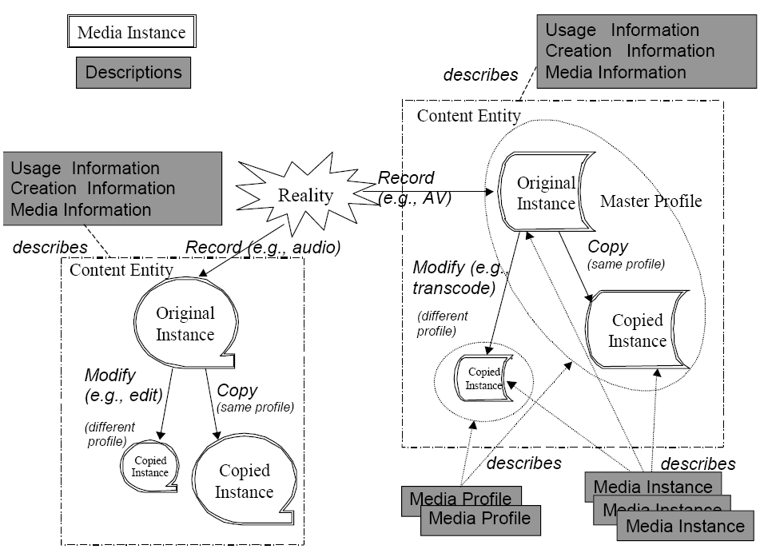
Figure 1: Illustration of the MPEG-7 concepts of content entity, modality, profile, and instance as they relate in media information. [2]

MediaInformation DS semantics:

Name | Definition
MediaInformationType | Describes the physical format of the multimedia data.
MediaIdentification | Identifies the multimedia content entity representing a reality (optional).
MediaProfile | Describes a media profile for the multimedia content.

MediaIdentification D

The MediaIdentification D is used to identify the multimedia content independently of the different available instances. The different media profiles of the multimedia content can be described using their media profile. Also for each media profile there can be multiple media instances.

MediaIdentification D semantics:

Name | Definition
MediaIdentificationType | Identifies the content entity independently of the different available profiles and instances.
EntityIdentifier | Identifies uniquely the particular and unique multimedia content entity. For example, ISO's ISAN.
AudioDomain | Describes the source, acquisition, and/or use of an audio content entity (optional). If a content entity is AV, AudioDomain and VideoDomain are used simultaneously. An example of CS is AudioDomainCS.
VideoDomain | Describes the source, acquisition, and/or use of a video content entity (optional). An example of CS is VideoDomainCS.
ImageDomain | Describes the source, acquisition, and/or use of an image content entity (optional). An example of CS is ImageDomainCS.

MediaProfile DS

The MediaProfile DS describes concrete profile of the multimedia content. The term “profile” refers to a new variation of the content that was produced from the original or master media by representing the content using different coding, storage format etc. The profile that corresponds to the original or master copy of the multimedia content is called the master media profile. For each profile there can be one or more media instances of the master media profile.

MediaProfile DS semantics:

Name | Definition
MediaProfileType | Describes the media profile of the multimedia content being described.
ComponentMediaProfile | Describes one component Media Profile of a multiplexed Media Profile, describing a multimedia content with different component multimedia contents (optional).
MediaFormat | Describes the format of the Media Profile (optional).
MediaTranscodingHints | Describes the transcoding hints of the Media Profile (optional).
MediaQuality | Describes the quality of the signal corresponding to the Media Profile (optional).
MediaInstance | Identifies and locates one Media Instance of the Media Profile (optional).
master | Indicates whether the Media Profile corresponds to the original or master profile of the multimedia content entity. Default value of this attribute is false.

MediaInstance DS

The MediaInstance DS is used to identify and locate the different media instances of a media profile.

MediaInstance DS semantics:

Name | Definition
MediaInstanceType | Describes the identification and the location of Media Instances.
InstanceIdentifier | Identifies the Media Instance or copy.
MediaLocator | Describes the Media Locator of a Media Instance.
LocationDescription | Describes the location of a Media Instance not available via a Media Locator. For example, the location of tapes stored in the analogue archive of a broadcaster.

Usage Information
The Usage Information DS is used to describe the usage information that relates to the audio-visual content (i.e. usage rights, usage record, and financial information). MPEG-7 description does not explicitly include the rights information, instead user is enabled to provide links to the rights holders or other information related to rights management and protection. The Rights DS is used to provide such references in the form of unique identifiers that are under management by external authorities.

UsageInformation DS semantics:

Name | Definition
UsageInformationType | Describes usage features of the multimedia content.
Rights | Describes information about the owners of the rights corresponding to the multimedia content, and how the multimedia content can be used (optional). Its appearance at this level precludes its appearance in the Availability DS instance of the same UsageInformation instance.
FinancialResults | Describes the cost of the creation of the multimedia content and the income the multimedia content has generated (optional). The incomes vary with time.
Availability | Describes where, when, how, and by whom the multimedia content can be used (optional).
UsageRecord | Describes where, when, how, and by whom the multimedia content was used (optional).

Rights Datatype

The Rights Datatype is used to describe links to the holders of rights of the multimedia content (IPR) and the holders of the Access Rights. Ownership of rights is not static so it can be transferred from one rights holder to another. It is necessary to enable users of the system to be able to discover the current rights situation. Rights Datatype is an identifier that can be resolved through an appropriate agency.

Rights datatype semantics

Name | Definition
RightsType | Describes a link to the right holders and to the access rights information. It gives an ID (such as specified in the MPEG-4 IP Identification Data Set) that enables access to the current Rights Owner information about the multimedia content or the description (making use of appropriate rights management databases).
RightsID | Identifies the link to the current Rights information about the content, including Rights Holders, Access Rights, and other related information.

Financial Datatype

The Financial Datatype is used to carry information about costs generated and incomes produced by multimedia content. The concepts of partial costs and incomes enable us to classify the various costs and incomes based on their type.

Financial datatype semantics
Name | Definition
FinancialType | Describes the costs and incomes generated by the multimedia content.
AccountItem | Describes an account item (cost or income).
EffectiveDate | Describes when the cost or income is made effective (optional). It can be the same as when it was generated or not.
CostType | Describes the type of a cost.
IncomeType | Describes the type of an income.
currency | Describes the currency of the price (see ISO 4217).
value | Describes the value of the price.

Availability DS

The Availability DS is used to describ the availability for use of the multimedia content. The Availability DSs are referenced by the UsageRecord DSs to keep track of the usage of the multimedia content.

Availability DS semantics:

Name | Definition
AvailabilityType | Describes the availability of the multimedia content. For example, broadcasting, on demand delivery, CD sales, and so forth.
InstanceRef | Describes a reference to the MediaInstance for which the availability is described.
Dissemination | Describes how the multimedia content is disseminated (optional).
Financial | Describes the financial information related to the particular use described in the Availability description (optional). For example, it allows the description of the price of using the content and additional costs due to the availability of the content.
Rights | Describes information about the owners of the rights corresponding to the multimedia content, and how the multimedia content can be used (optional). Its appearance at this level precludes its appearance in the Rights instance of the same UsageInformation instance.
AvailabilityPeriod | Describes one period (date, time, and duration) of availability of the multimedia content (optional). For example, time and date of the broadcast, or time and date of availability for an on-demand content. In the case of availability on a persistent medium (e.g, DVD), it specifies the date of publication. If there is no duration description, the duration of the availability is unbounded.
type | Indicates the types of availability of the period (optional): live – Indicates the multimedia content is made available (e.g, broadcast) live. repeat – Indicates the multimedia content is a repeat of multimedia content that has been made available earlier (e.g, broadcast). firstShowing – Indicates the given availability period is the first showing of the multimedia content. lastShowing – Indicates the given availability period is the final showing of the multimedia content. conditionalAccess – Indicates the access to the multimedia content is restricted by a conditional access mechanism. encrypted – Indicates the multimedia content is encrypted for restricted viewing. payPerUse – Indicates the multimedia content is pay-per-use (e.g. pay-perview). Other values that are datatype-valid with respect to mpeg7:termReferenceType are reserved.

Semantics of the DisseminationType:

Name | Definition
DisseminationType | Describes the dissemination mechanism of the multimedia content.
Source | Describes the source of the content, referring to, for example, a broadcast channel or a server.
Format | Describes the publication medium or delivery mechanism of the multimedia content, for example, terrestrial broadcast, web-cast, streaming, CD-ROM, etc. (optional). An example of CS is DisseminationFormatCS.
Disseminator | Describes the disseminator of the multimedia content (optional). The disseminator refers to the agent or organization that makes the content available.
Location | Describes the place from which the multimedia content is disseminated (optional).

UsageRecord DS

The UsageRecord DS is used to describe the past use of the multimedia content.

UsageRecord DS semantics:

Name | Definition
UsageRecordType | Describes past use of the multimedia content.
AvailabilityRef | Describes a reference to the content availability's description.
Audience | Specifies the number of users who used the multimedia content in the particular use described in the referenced Availability description (optional).
Financial | Describes the financial information related to the particular use that is described in the referenced availability description (optional).

Standard NISO Z39.87 -200x – Data Dictionary
This standard defines Technical Metadata for Digital Still Images [1]. It still in draft form, this survey is based on second ballot version (May 1, 2006 - June 15, 2006). It enables user to capture various administrative metadata information described in following sections.

Identification
Every still digital image is identified by unique ObjectIdentifier that comprises from two fields: objectIdentifierType and objectIdentifierValue.
Field objectIdentifierType contains information concerning given type identification (examples: Content Management System, MARC organization code, local photograph accession system). Field objectIdentifierValue contains actual unique identification value (examples: CUL2435.67, bl.natlib/news2003.4567, codhawp 00130296, http://photoswest.org/cgi-bin/imager?00130296+C-296 )

Source information
NISO standard enables user to create metadata concerning source of still image. Logical structure of metadata concerning source is on Figure 2.

Field sourceType contains information about original source of digital data (examples: photograph, daguerreotype, reflection print, gelatin silver print, Acme Bronze 100 chromogenic film, 35 mm color negative Kodak Royal Gold 100 Emul. 3712011, text document or book, microfilm, sculpture, original scene, contact sheet A)

Following fields in source information container contain specifications of source defined in field sourceType.

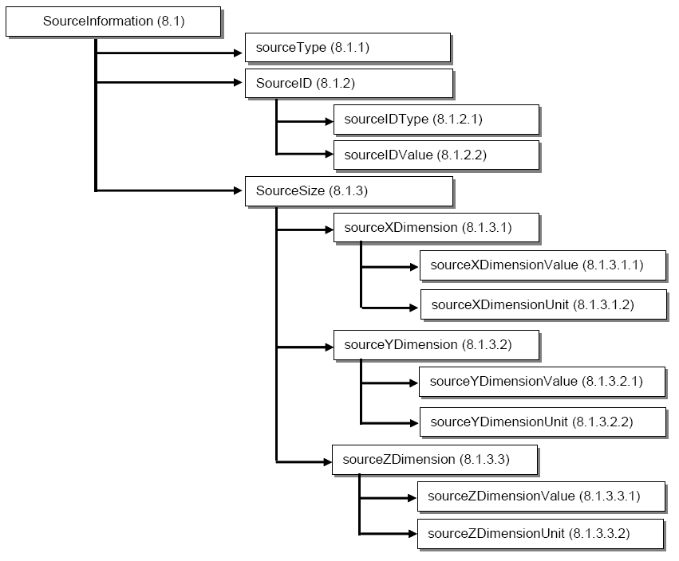
Figure 2: Logical structure of metadata concerning source of still image. [1]

General Capture Information
Metadata concerning creation of digital still images:

dateTimeCreated
imageProducer
captureDevice

Based on type of captureDevice – transmission or reflexion print scanner, digital camera or still image from video data – there can be additional technical information concerning this device. Logical structure of information for scanner device is on Figure 3. Logical structure of information for digital camera device is on Figure 4. Metadata stored for digital camera still images are based on EXIF standard.

NISO standard also contains methodology field (8.6) which is “a data element that designates the methodology and rationale to digitize an object or collection” [1]. Unfortunately this field is not further structured or formalized.

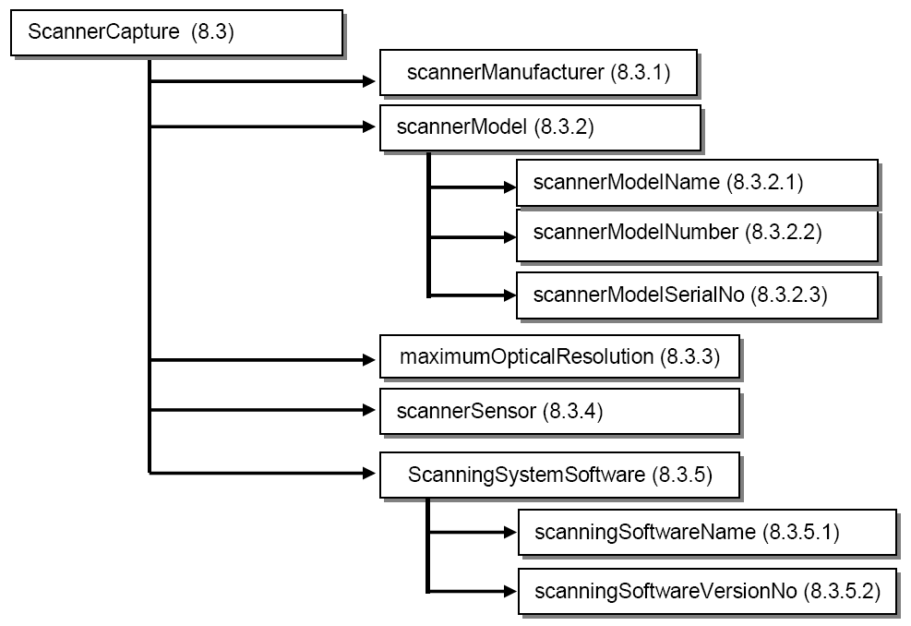
Figure 3: Logical structure of information for scanner device

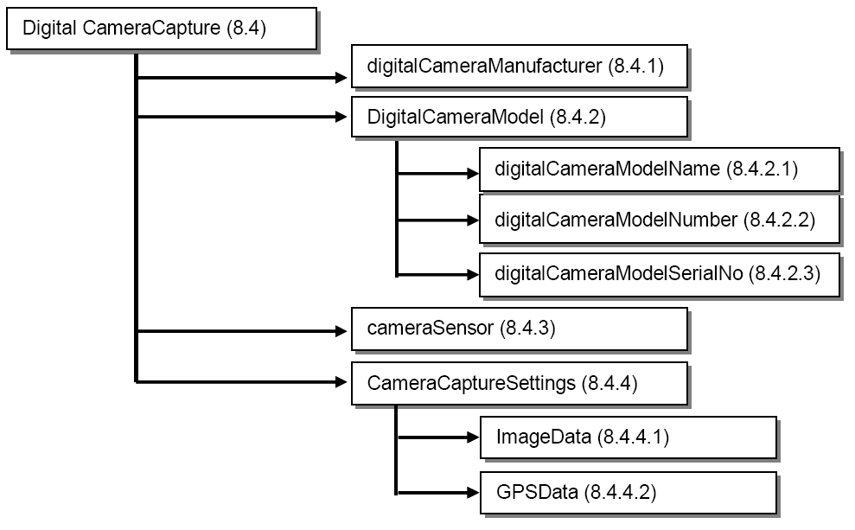
Figure 4: Logical structure of information for digital camera device. [1]

Conclusion
This document presents overview of administrative metadata and other relevant description tools in MPEG-7 standard. Also some important aspects of NISO Z39.87 -200x standard draft are presented.

References

[1] Standard NISO Z39.87 -200x – Data Dictionary - Technical Metadata for Digital Still Images. http://www.niso.org/standards/standard_detail.cfm?std_id=731

[2] MPEG-7 Overview. http://www.chiariglione.org/mpeg/standards/mpeg-7/mpeg-7.htm
[APPENDICIES – as appropriate]

